Project Proposal

Project Name: Catherine Creek Elmer-Hassinger Wetland and Rearing Habitat

Project Sponsor:
Grande Ronde Model Watershed Foundation (GRMWF)
1114 J Avenue
La Grande, OR 97850
541-663-0570

Participating Landowners and Agencies
Grande Ronde Model Watershed Program (GRMWP) (sponsor
Howard & Cherie Elmer (landowner)
Phil & Trudy Hassinger (landowner)
Anderson Perry & Associates (designs)

Project Contact(s):
Grande Ronde Model Watershed Program (technical)
- Lyle Kuchenbecker, 541-663-0570, lyle@grmw.org

Grande Ronde Model Watershed Foundation (administrative)
- Mary Estes, 541-663-0570, mary@grmw.org

Howard & Cherie Elmer Phil & Trudy Hassinger
67750 Lower Cove Rd 68333 Kerns LP
Cove, OR 97824 Cove, OR 97824

Project Location:
The project area is located on Catherine Creek approximately 12 miles above the confluence of Catherine Creek and the Grande Ronde River. Legal description: T2S, R40E, Sec. 19, SW ¼ of the NW ¼ and NW ¼ of the SW ¼

Project Objectives:
Limiting factors for Catherine Creek identified in the Grande Ronde Subbasin Plan are:
- Habitat quantity
- Habitat diversity
- Sediment
- Flow
- Temperature

The project will directly address habitat quantity and habitat diversity, and will indirectly address sediment, flow and temperature.

Specific Objectives are:
- Increase quality and quantity of off-channel salmonid rearing habitat by reactivating about 2000 feet old stream channel
- Increase water storage for late season release (potential late-season flow increase and temperature decrease)
- Restore connectivity between stream channel and adjacent landscape
- Improve habitat for wetland and riparian-dependent species

Introduction and Background
Catherine Creek is critical habitat for ESA listed Snake River summer steelhead, spring Chinook and bull trout as well as resident rainbow and other native fish. This reach of Catherine Creek is a migration corridor and provides juvenile winter rearing habitat. Lower Catherine Creek historically meandered a great deal in the reaches above what is now the confluence with the Grande Ronde River. This channel actually used to be the Grande Ronde River before the construction of the State Ditch in the late 1800’s. Over the years some channel reaches were naturally cutoff, creating oxbows. Many reaches were intentionally cutoff throughout the early and mid-1900’s with the same result. Levee construction to protect agricultural lands was also a common practice. Most often levees were constructed immediately adjacent to the stream channels disconnecting riparian habitats and the stream channel. The project proposes to create seasonal wetland habitat and salmonid rearing habitat adjacent to lower Catherine Creek by relocating a dike and opening up an oxbow.

Existing Condition:
Historically the Grande Ronde River flowed through this reach of Catherine Creek. In the 1870’s the State Ditch was constructed to cut off a large segment of the Grande Ronde River with the intent of developing agricultural lands and reducing flooding. Since that time Catherine Creek has flowed through this channel. Approximately 50 years ago a two hundred foot channel was dug to short-cut about 2000 feet of Catherine Creek. The old channel was plugged at the upper end but left open at the lower end. Over the years the lower end of the oxbow has silted in, cutting off the oxbow from the main channel during low-flow periods. At about the same time a levee was constructed along the east side of the oxbow and the live channel. Water backs up into the oxbow during periods of high flow.

Proposed Actions:
- Remove approximately 2000 feet of the existing dike adjacent to the Catherine Creek channel and the oxbow
- Construct approximately 2500 feet of a new dike 50-250 feet back from the stream channel
- Excavate material within the new flood zone to create more permanent wetlands (ingress and egress provided back to the channel) as per designs
- Remove existing water control structures in the old dike (concrete and headgates)
- Open bottom end of oxbow by removing sediment buildup in the lower approximate 500 feet of the oxbow channel
- Install a 48”culvert through the channel plug at the upper end of the oxbow (free flowing, no headgate)
- Erosion seed disturbed ground with native shrubs, forbs and grasses

Benefits:
Juvenile steelhead and Chinook will have access to an additional 2000 feet of the oxbow for winter rearing habitat and off-channel refuge during high flows. Habitat diversity in the channel will be maintained by providing only minimal flow through the oxbow and not converting it to the main channel. The additional approximate 6 acres of seasonally flooded ground will promote the establishment of riparian vegetation, increase water storage in the soil profile and improve the connectivity between the stream channel and adjacent landscape. The additional 6 acres of non-cropped land will provide habitat for many riparian as well as upland species. This habitat is limited in the intensive agricultural lands along lower Catherine Creek.

Project Schedule:

Initial planning for this project included a levy setback in order to improve the hydraulic function of the river and create seasonal wetlands. The GRMW conducted a BiOp technical committee site visit in 2009. Upon further discussion with the TC in the field it seems there may be the opportunity to re-active an old oxbow channel and provide greater species benefits. The TC and BPA gave their support for this expanded project. The GRMW discussed the idea with ODFW. It was decided the most fish benefit would be derived by activating the oxbow as a backwater rearing habitat and not turning it into the main channel. The GRMW approached the landowners with the expanded concept and the landowners agreed.

- March – April, 2010 Complete engineering designs
- April – May, 2010 Consummate Landowner Agreement, complete ESA Consultation
- April - July, 2010 Obtain COE and DSL permits
- July – October 15, 2010 Construction
- July – October 15, 2011 Construction

Work outside of the ordinary high water zone can occur anytime the ground is dry enough for equipment. Work below ordinary high water will occur within the in-water work period July 1 to October 15. Anderson-Perry & Associates (AP) of La Grande, Oregon have completed the site survey, preliminary designs, final designs and cost estimates. AP will complete applications for Department of State Lands and Corps of Engineers permits. Landowners are amenable to participating in the USFWS Partners Program. ESA consultation has been completed via the USFWS Partners Programmatic Biological Opinion. Cultural Resource SHPO and Tribal clearance has been obtained for levee relocation but not excavation in the oxbow. The additional cultural resource survey and report have been completed and paperwork submitted to BPA for distribution to Oregon SHPO, CTUIR and Nez Perce Tribe.

Project Maintenance
The project should require very limited maintenance once vegetation becomes established. During vegetation establishment, and periodically thereafter, the landowners will monitor and control noxious weeds.

Monitoring
The GRMW will prepare the Final Completion Report and conduct post-project monitoring. Post-project monitoring will consist of the following:
- Establishment of at least 6 permanent photo-points
- Annual report describing status of the project including vegetation, performance of the new levee and water control structures
- The GRMW will coordinate periodic juvenile fish presence surveys (winter/spring)

Vicinity Map
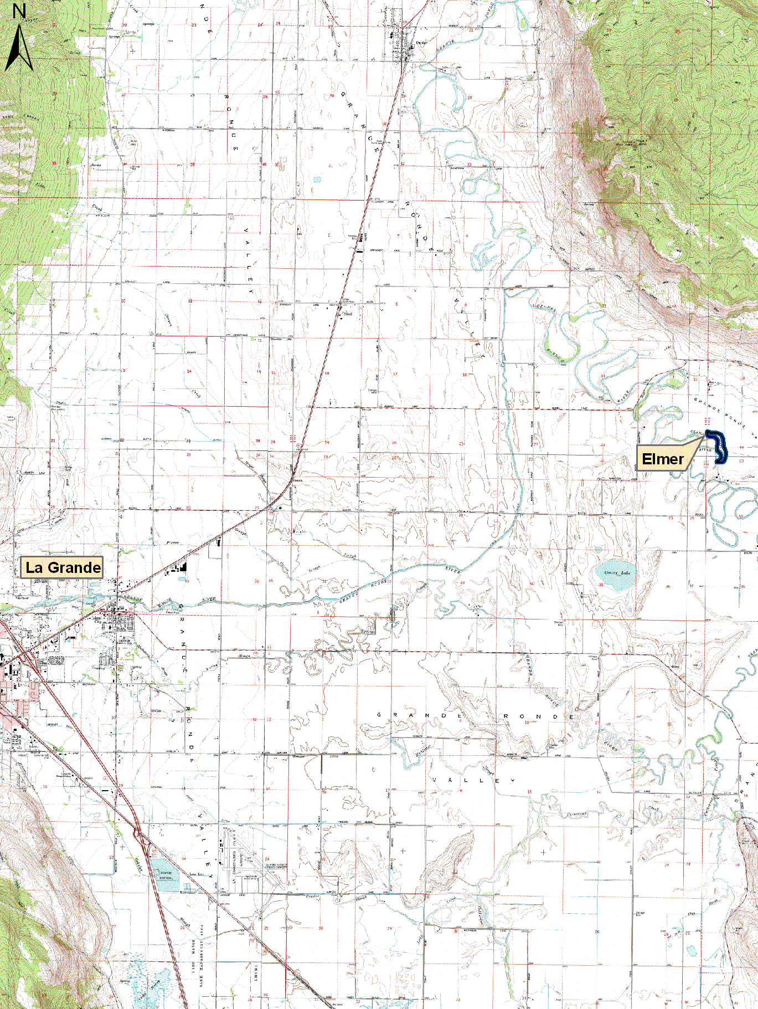

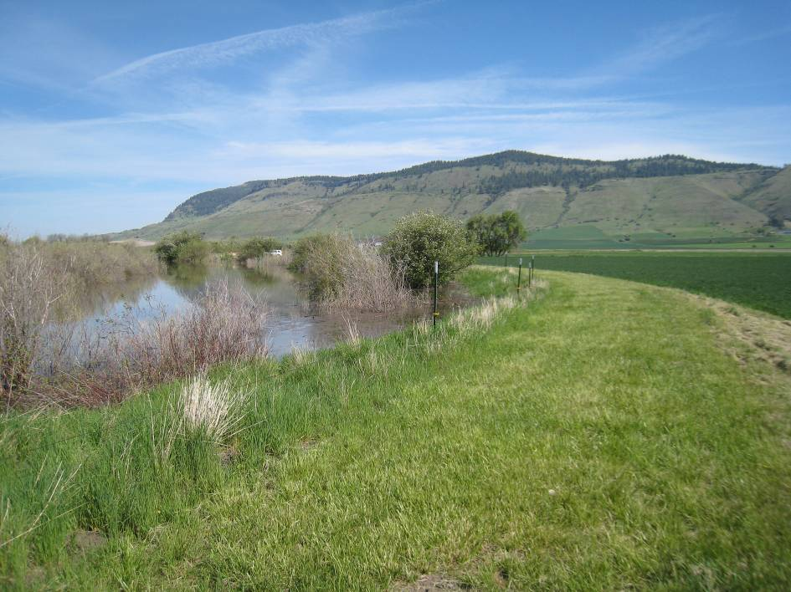
Catherine Creek up against the existing dike

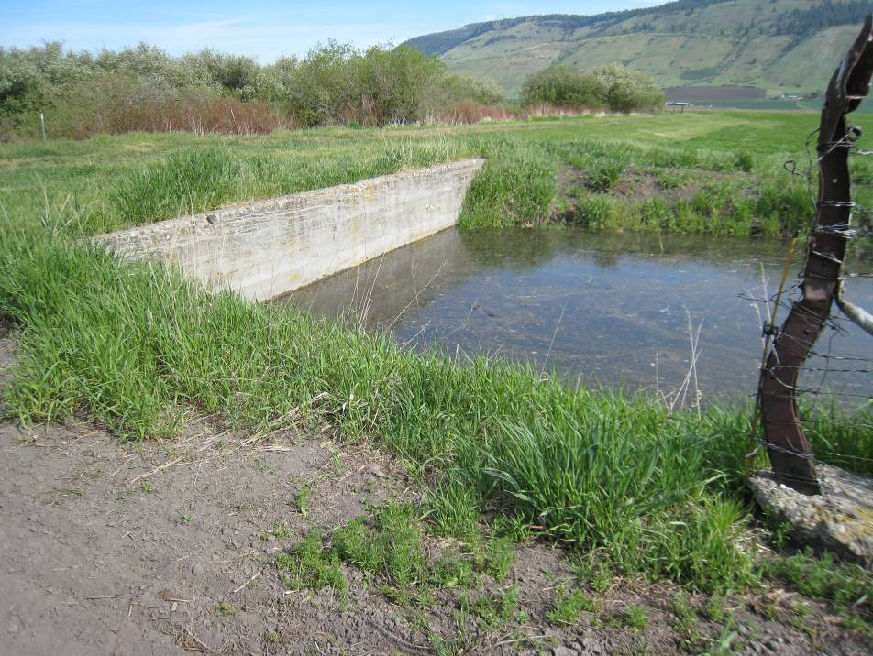
Old concrete water control structure in existing dike

